LESSON 3 A2+

**Ask different students questions:**

What city do you live in? Do you sometimes go on trips? Where did you go on your last trip?

I live in Cipolletti. Yes, sometimes I go on trip

When was your last trip? Do you sometimes go on business trips? When you travel, do you go to a travel agent for your tickets?

My last trip was in march. Two twice a years I go on business trips. When I go on business trips the travel agent get my ticket.

Do you sometimes buy tickets online? Do you use your computer?

When I go on holiday I buy my tickets online, I use my phone.

Do you sometimes stay in hotels?

Sometimes I stay in hotels, and sometimes I stay in a apartment because I prefer cook my food, and I eat health

What is your favorite way to travel—for example, by plane or train?

My favorite way to travel is by plane and train. I prefer take a train for movie between cities.

Do you enjoy traveling?

I enjoy traveling ¡¡ I love traveling

Do you sometimes speak English when you travel?

When I going to Europe or EEUU I will try practice my English

When you travel, do you sometimes miss your family and friends?

NO I never miss my family and friends because when I travel I will do everything in each city, I don’t have any time

Do you like to eat in restaurants?

Yes like to eating in restaurants, but sometimes I prefer cook health food.

What kind of food do you like to eat in restaurants

I like to eat in restaurant a typical food of the city, but I prefer fish, vegetables, and salad.

When you travel, do you sometimes take a taxi?

No, I never take a taxi when I travel. I take a subway.

Do you sometimes rent a car?

Depends, when I need to move between cities, I prefer rent a car.

Do you sometimes go to a foreign country?

Yes, I go to a foreign country ones a year

Where would you like to go on your next trip?

I would like to go to New York.

When you are traveling, what do you usually do in the evening?

When I am traveling, I usually planner the next day in the evening.

**Main Activity 1: Max’s Business Trip**

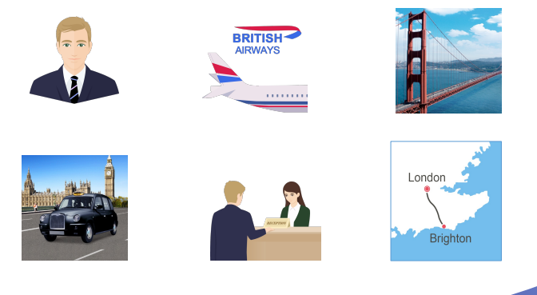

**Here you can see pictures about Max’s business trip. You studied about it in neo. I’m going to read you some information about this trip.**

Next week, Max is going on a business trip. He’s going to fly from San Francisco to London. He bought his airplane tickets from British Airways because he could get a non-stop flight. He’ll leave San Francisco on Saturday and arrive in London on Sunday morning. After he arrives at the airport in London, he’ll get his baggage and go through customs. He’ll be very tired, so he’ll take a taxi to his hotel and check in. The next day, Monday, he’ll have many business meetings. On Tuesday, he’s going to take a train from London to Brighton to meet his good friend John. For dinner, they always go to an excellent restaurant, drink fine wine, and talk about their families and about their lives. After dinner, Max will take the train back to London. Max will return to San Francisco on Wednesday.

1. When is Max flying to London? Max is flying to London on Saturday .

C. Max’s flight is on Saturday.

2. Why does he want to take a flight on British Airways? Because it get a non-stop flight

3. What day is Max leaving? Max is living on saturday

4. When will Max arrive in London? Max will arrive in London on Sunday.

5. How will Max get from the airport to his hotel? (B) He is going to get to the hotel by taxi. He is going to take a taxi to get to the hotel

6. What does Max do at the hotel? Max will check in. (A)

7. What does he have to do the next day, Monday? On Monday he have to attend a meeting

8. When is John going to Brighton? On Tuesday John is going to Brighton.

9. Why is John going to Brighton? Because he is gong to meet his friend

10. What do Max and John always do? They always go out, or go to an excellent restaurant

11. After dinner, what will Max do? After dinner Max is going to back to London

12. When is Max flying back to San Francisco? Max is flying back to SF on Wednesday

A. Once he arrives at his hotel, he'll check in. What does Max do at his hotel?

B. If he's tired, he may decide to take a taxi. How is max going to get to the hotel? How will max get to the hotel?

D. Max is going to get the ticket in the mail tomorrow. When is max going to get the ticket?

E. Yesterday his travel agent called and told him there was space on the flight. When did travel agent call him?

F. On the other hand, he may decide to take a bus. How many options does he have to get to the hotel?

G. Max is going to arrive in London on a Sunday. When is max going to arrive in London?

H. Then he'll have to decide how to get to his hotel. What will he have to decide after his arrival?

I. Next week Max is going on a business trip. What is Max going to do next week?

J. He tried to buy airplane tickets last week, but the flight was full. When did he try to buy airplane tickets?

K. When he lands in London, he'll claim his baggage and go through customs. What will he do when he arrives to london?

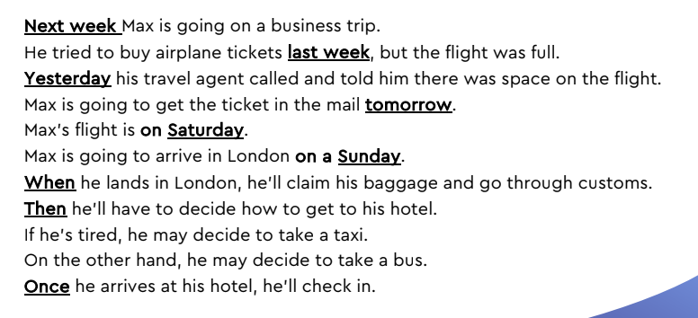

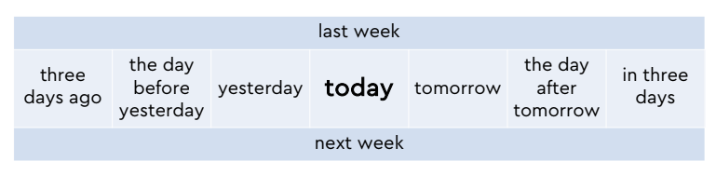

PAG 106/107 LIFE 2E

